**Using Conda Python Environments with Spyder IDE and Jupyter Notebooks in Windows**



Requirements for following the steps:  
> We need Anaconda Installed, link for that  
[***https://www.anaconda.com/products/individual***](https://www.anaconda.com/products/individual)  
> select the version to download and install

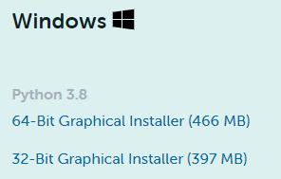

**1. Creating new environment with pip**

This step has lot of help everywhere, just to refresh up  
Use Anaconda Prompt for the following steps:  
> Check the available environments  
***conda env list***

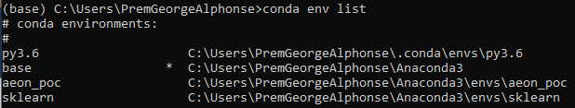

this will list all the available environments that are created before.

> To create an new environment:  
***conda create -n env_name***  
or with python version  
***conda create -n env_name python=3.7.4***

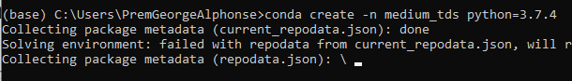

> When conda asks you to proceed, type y



> Once created we see

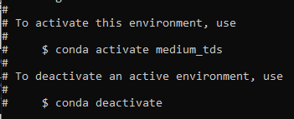

> To activate the environment, type  
***conda activate env_name***



> Now we can do pip install packages  
> Check the list of environments

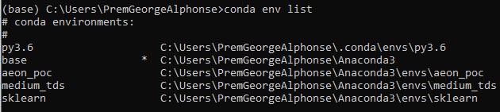

> To get the path of the new environment  
***python -c “import sys; print(sys.executable)”***This is the path to be used in Spyder python interpreter to change the environment for spyder



> To deactivate the environment (no need for env_name)  
***conda deactivate***

> To delete an environment  
***conda remove -n env_name --all***

**2. How to use the new environment in Jupyter**

> To set the conda environment for jupyter,  
First we have to install kernel  
install ipykernel inside the environment with following cmd  
***conda install -c anaconda ipykernel***



> proceed y to continue



> check the installed kernel specs with the following cmd  
***python -m ipykernel install --user --name=env_name***



> Run Jupyter Notebook as  
***jupyter notebook***



Open the jupyter browser , you can see the new environment in the ‘New’ dropdown,

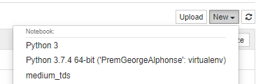

selecting that will open a new notebook, to confirm the environment, type  
***import sys  
print(sys.executable)***

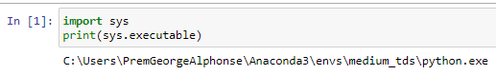

**3. How to use the new environment in Spyder**

> To set the conda environment for Spyder,  
First we have to install kernel  
install spyder kernel inside the environment with following cmd  
***pip install spyder-kernels***



> Get the path of the new environment as we did before, copy the path



> Now open the spyder IDE, under the console, at the bottom we can see the current environment, it should be conda base environment like



> To change that, Open Tools -> preferences

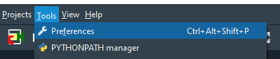

> in python interpreter, which is set as default initially

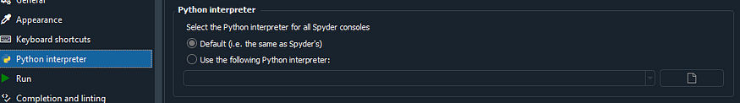

> select the ***“Use the following Python interpreter:”*** and paste the path as below and click Apply and OK

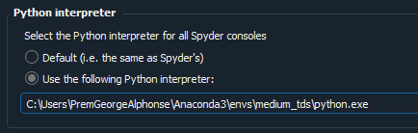

> now we can use the new environment in spyder



> To check the environment, restart the kernel from the console like below

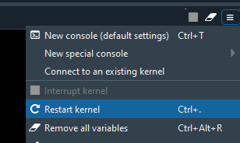

> run the code  
***import sys  
print(sys.executable)***



Hope this helps :)